Install Behave:

pip install git+https://github.com/behave/behave

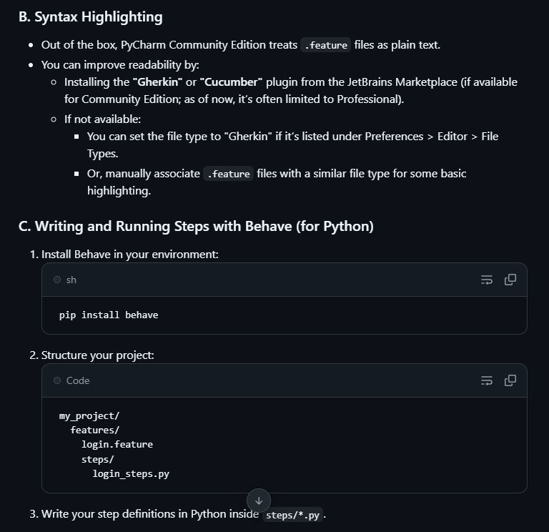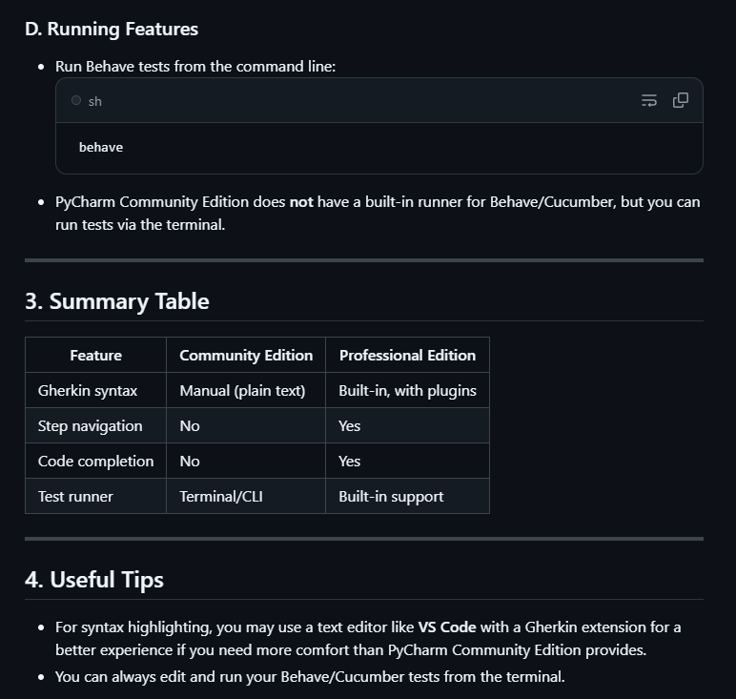

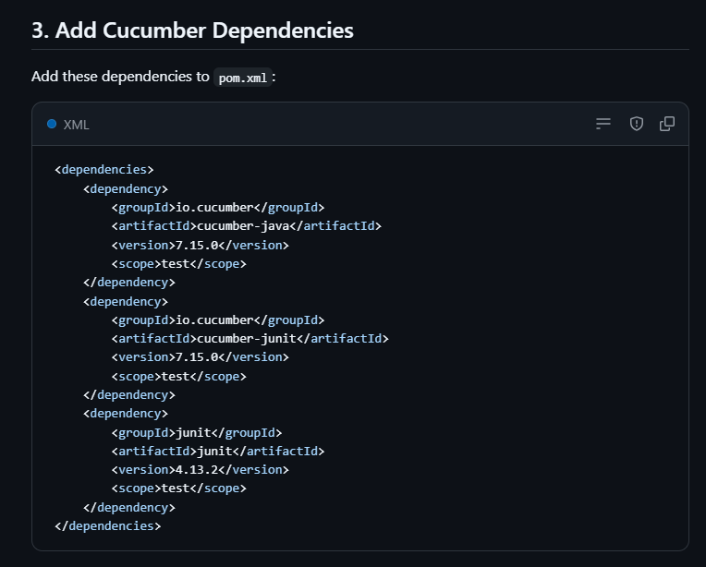<dependencies>

<dependency>

<groupId>io.cucumber</groupId>

<artifactId>cucumber-java</artifactId>

<version>7.15.0</version>

<scope>test</scope>

</dependency>

<dependency>

<groupId>io.cucumber</groupId>

<artifactId>cucumber-junit</artifactId>

<version>7.15.0</version>

<scope>test</scope>

</dependency>

<dependency>

<groupId>junit</groupId>

<artifactId>junit</artifactId>

<version>4.13.2</version>

<scope>test</scope>

</dependency>

</dependencies>

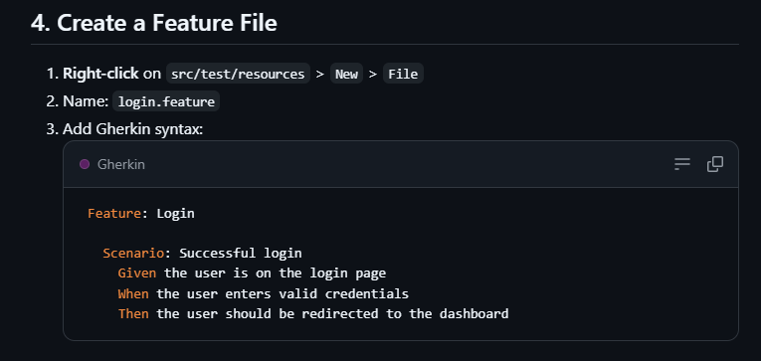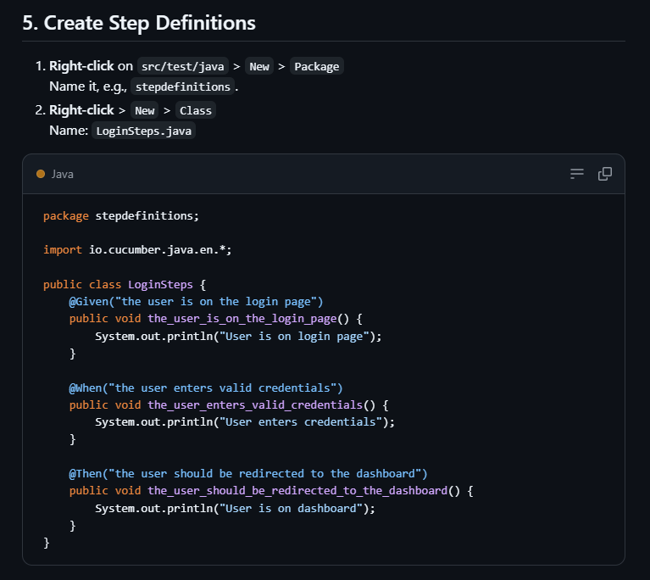package stepdefinitions;

import io.cucumber.java.en.*;

public class LoginSteps {

@Given("the user is on the login page")

public void the_user_is_on_the_login_page() {

System.out.println("User is on login page");

}

@When("the user enters valid credentials")

public void the_user_enters_valid_credentials() {

System.out.println("User enters credentials");

}

@Then("the user should be redirected to the dashboard")

public void the_user_should_be_redirected_to_the_dashboard() {

System.out.println("User is on dashboard");

}

}

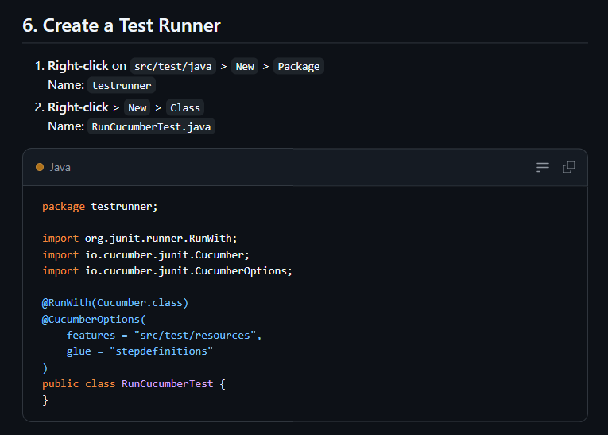package testrunner;

import org.junit.runner.RunWith;

import io.cucumber.junit.Cucumber;

import io.cucumber.junit.CucumberOptions;

@RunWith(Cucumber.class)

@CucumberOptions(

features = "src/test/resources",

glue = "stepdefinitions"

)

public class RunCucumberTest {

}

